Project Title: Smart Scheduler
A Role-Based Institute Management & Timetable Generation System using a Constraint Satisfaction Problem (CSP) Solver
Course Name:
Full Stack Web Development
Course Code:
CS-300

Submitted By:
Roll No | Member Name
233553 | Muhammad Maaz
233505 | Syed Muhammad Sarib
233543 | Muhammad Bilal Talib
Submitted To:
Muhammad Rashaf Jamil
Department:
Department of Computer Science
University Name:
Air University Multan Campus
Semester & Year:
5th (2025-2026(3rd))
Declaration
I hereby declare that the work presented in this Final Year Project report titled "Smart Scheduler: A Role-Based Institute Management & Timetable Generation System using a Constraint Satisfaction Problem (CSP) Solver" is my own original work, carried out under the supervision of Muhammad Rashaf Jamil Khan. This work has not been submitted previously, either in whole or in part, to qualify for any other academic award at this or any other university or institution. All sources of information, references, and assistance received during the course of this project have been duly acknowledged and properly cited in this report.
Student Name: ____________________
Signature: ____________________
Date: ____________________

Approval
This is to certify that the Final Year Project titled "Smart Scheduler: A Role-Based Institute Management & Timetable Generation System using a Constraint Satisfaction Problem (CSP) Solver" has been successfully carried out by Muhammad Maaz, Syed Muhammad Sarib, and Muhammad Bilal Talib under my supervision and guidance. The work presented in this report meets the required standards and is hereby accepted as partial fulfillment of the requirements for the award of the degree of (BS) in (Computer Science).
Supervisor: ____________________
Signature: ____________________
Date: ____________________

Acknowledgements
We would like to express our sincere gratitude to our supervisor, M. Rashaf Jamil Khan, for his continuous guidance, invaluable support, and constructive feedback throughout the duration of this project. His expertise and encouragement have been instrumental in the successful completion of this work.

Abstract
Timetable scheduling in educational institutions is a challenging and resource-intensive process, primarily due to the need to satisfy numerous overlapping constraints such as room and instructor availability, class section requirements, lab durations, scheduled breaks, and institutional working hours. Manual approaches are not only time-consuming but also susceptible to conflicts and errors, especially as the scale and complexity of the institute increase.
Smart Scheduler addresses these challenges by providing a web-based, Software-as-a-Service (SaaS) platform for academic timetable generation and institute management. The system supports multiple user roles including Owner, Admin, Teacher, and Student enabling secure, role-based access to relevant features. Built using the MERN stack (MongoDB, Express.js, React, Node.js) for the main application and a dedicated Python FastAPI micro service for timetable generation, Smart Scheduler leverages a Constraint Satisfaction Problem (CSP) solver to automate the scheduling process.
The CSP solver models each teaching session as a variable and assigns it a feasible room, day, and time slot, ensuring compliance with hard constraints such as avoiding overlaps, respecting break times, and scheduling labs in consecutive slots. Additionally, the solver incorporates soft constraints to optimize for preferences like distributing sessions across the week, minimizing idle gaps, and reducing repetitive back-to-back classes. For each scheduling request, the system generates three candidate timetables using different random seeds, allowing administrators to review and select the most suitable option.
By automating timetable generation and integrating institute management features, Smart Scheduler significantly reduces administrative workload, minimizes scheduling conflicts, and enhances operational efficiency for educational institutions.
Table of Content
Chapter 1 - Introduction 6
1.1 Background 6
1.2 Project Overview 6
1.3 Scope 7
1.3.1 Features Within Project Scope 7
1.3.2 Features Outside Current Scope 9
Chapter 2 - Problem Statement and Objectives 10
2.1 Problem Statement 10
2.2 Objectives 11
2.2.1 Primary Objectives 11
2.2.2 Secondary Objectives 12
Chapter 3 - Literature Review 13
3.1 Timetable Scheduling Approaches 13
3.2 Why CSP Fits This Project 13
3.3 CSP Heuristics Used 13
Chapter 4 - System Analysis and Requirements 14
4.1 User Roles 14
4.2 Functional Requirements 14
4.3 Non-Functional Requirements 14
Chapter 5 - System Design 15
5.1 High-Level Architecture 15
5.1.1 Component Diagram (Logical) 15
5.2 Backend Design (Express) 15
5.3 Database Design (MongoDB) 16
5.3.1 Timetable Storage Strategy 16
5.4 Frontend Design (React) 16
Chapter 6 - Implementation 17
6.1 Technology Stack 17
6.2 Authentication and Authorization 17
6.3 Subscription Enforcement 17
6.4 Timetable Generation Flow (End-to-End) 17
6.5 CSP Solver Design (Python FastAPI) 18
6.5.1 CSP Modeling 18
6.5.2 Hard Constraints (Must Satisfy) 18
6.5.3 Soft Constraints (Preferences) 18
6.5.4 Search Strategy 19
Chapter 7 - Testing and Validation 20
7.1 Testing Strategy 20
7.2 Python Solver Realistic Test 20
7.3 Validation Criteria 21
Chapter 8 - Results and Discussion 22
8.1 Timetable Generation Output 22
8.2 Performance Analysis 22
8.3 System Strengths 23
8.4 Current Limitations and Trade-offs 23
Chapter 9 - Deployment and User Guide 25
9.1 Local Deployment (Development) 25
9.2 Environment Variables (Typical) 25
9.3 Admin Workflow (Timetable) 25
Chapter 10 - Conclusion and Future Work 26
10.1 Conclusion 26
10.2 Future Work 27
References 29
Appendices 30
Appendix A - Key API Endpoints (Backend) 30
Appendix B - Python Scheduler Endpoint 30
Appendix C - Data Model Summary (Core Fields) 30
Appendix D - Timetable Payload Structure 31

Chapter 1 - Introduction

1.1 Background
Timetable creation in educational institutes is a complex and critical administrative task. It involves assigning classes, teachers, rooms, and time slots in a way that satisfies a wide range of overlapping constraints, such as teacher availability, room capacity, class sections, lab durations, scheduled breaks, and the institute’s operational hours. As the size and complexity of an institute increase, manual scheduling becomes not only time-consuming but also prone to errors and conflicts, such as double-booking teachers or rooms, or failing to allocate required breaks. These issues often necessitate repeated manual adjustments, leading to inefficiency and frustration for both administrators and staff. Therefore, there is a growing need for automated solutions that can efficiently generate conflict-free timetables while accommodating all necessary constraints.

1.2 Project Overview
Smart Scheduler is a comprehensive, web-based institute management and timetable scheduling platform designed to automate the complex process of academic scheduling while providing robust administrative capabilities. The system employs a modern, service-oriented architecture comprising three primary components:
Frontend Layer: A responsive React 18 single-page application that provides an intuitive user interface for all stakeholders, including institute owners, administrators, teachers, and students. The frontend implements role-based dashboards, multi-step wizards for timetable generation, and real-time data visualization using Chart.js.
Backend Layer: A Node.js/Express RESTful API server that handles business logic, authentication, and data persistence. This layer manages user authentication via JWT (JSON Web Tokens), enforces role-based access control, orchestrates communication between frontend and database, and coordinates with the scheduling microservice. The backend connects to MongoDB for storing institutional data, user profiles, and generated timetables.
Scheduling Microservice: A dedicated Python FastAPI service that implements a sophisticated Constraint Satisfaction Problem (CSP) solver for automated timetable generation. This isolated microservice applies advanced heuristics (MRV, LCV, Forward Checking) to produce conflict-free schedules while optimizing for institutional preferences.
Core Functionality:
The platform provides end-to-end institute management capabilities, including:
Institute Onboarding: Streamlined registration workflow for institute owners and initial setup processes
User Management: Comprehensive user administration supporting multiple roles with hierarchical permissions
Academic Configuration: Management of core institutional entities including classrooms, academic classes, courses, and time slot definitions
Automated Timetable Generation: CSP-based scheduling that produces three candidate timetables for administrative selection
Communication Module: Integrated feedback and messaging system enabling bidirectional communication between users and administrators
Subscription Management: Complete payment lifecycle handling via Stripe integration, supporting Trial, Monthly, and Yearly subscription plans
Timetable Storage and Distribution: Persistent storage of approved timetables with role-specific viewing capabilities

1.3 Scope

1.3.1 Features Within Project Scope
The current implementation encompasses the following functional modules:
Authentication and Authorization:
- Secure multi-role authentication system using JWT tokens
- Role-based access control (RBAC) enforcing permissions for Owner, Admin, Teacher, and Student roles
- Protected API endpoints and frontend route guards ensuring authorized access
- Institute Configuration and Management:

- Institute registration and profile management
- Academic resource configuration (rooms, classes, courses)
- Institutional time window definition for scheduling constraints
- Subscription plan selection and status monitoring
Academic Entity Management (CRUD Operations):
- Room management with capacity and type specifications
- Class configuration including degree programs, sessions, years, and sections
- Course catalog management with credit hours and lecture/lab type designation
- Time slot definition for institutional working hours and break periods
Timetable Generation and Management:
- CSP-based automated timetable generation producing three candidate schedules
- Interactive candidate selection interface for administrators
- Timetable persistence and version control
- Role-specific timetable viewing (admin, teacher, and student perspectives)
Communication and Feedback:
- Threaded feedback system for user-administrator communication
- Message reply functionality within feedback threads
- Institute-specific feedback isolation
Payment and Subscription System:
- Stripe-powered payment processing
- Subscription tier enforcement (Trial, Monthly, Yearly)
- Payment history tracking
- Automated subscription expiry management with grace periods

1.3.2 Features Outside Current Scope
The following features, while valuable for future enhancements, are not implemented in the current version:
Intelligent Preference Learning:
- Automatic detection and learning of instructor scheduling preferences
- Historical pattern analysis for schedule optimization
- Machine learning-based preference prediction
Collaborative Editing:
- Real-time multi-user simultaneous timetable editing
- Live conflict detection during manual adjustments
- Collaborative annotation and commenting on schedules
Advanced Analytics and Reporting:
- Comprehensive utilization metrics beyond basic dashboards
- Predictive analytics for resource planning
- Detailed performance reports and trend analysis
- Customizable report generation and export features

Chapter 2 - Problem Statement and Objectives

2.1 Problem Statement
Educational institutions face significant challenges in creating academic timetables due to the complexity of satisfying multiple overlapping constraints simultaneously. Manual scheduling processes are time-consuming, error-prone, and often result in conflicts that require repeated adjustments. As institutional size and complexity increase, these challenges become increasingly difficult to manage.
Key Requirements:
Modern educational institutes require a timetable generation solution that fulfills the following critical criteria:
- Computational Efficiency: The system must generate complete, conflict-free schedules within reasonable timeframes to support on-demand generation and enable administrators to make quick adjustments when needed.
- Correctness and Conflict Resolution: Generated timetables must be completely conflict-free, ensuring no resource (rooms, instructors, or class sections) is double-booked. All hard constraints must be rigorously satisfied without exceptions.
- Flexibility and Adaptability: The solution must accommodate diverse institutional requirements including variable break times, laboratory sessions requiring consecutive time slots, lectures of varying durations based on credit hours, and different room types for specialized courses.
- User-Friendly Interface: Administrators need an intuitive, web-based interface that simplifies the scheduling process without requiring technical expertise in optimization algorithms. The system should provide role-appropriate access for all stakeholders.

2.2 Objectives
This project aims to develop Smart Scheduler, a comprehensive web-based timetable generation and institute management system that addresses these challenges through automated constraint satisfaction techniques.

2.2.1 Primary Objectives
1. Complete Institute Management System with Role-Based Access Control
- Implement secure authentication and authorization supporting four distinct user roles: Owner, Admin, Teacher, and Student
- Enable institute onboarding workflow with owner registration and initial configuration
- Provide role-specific dashboards and functionality tailored to each user type
2. Automated CSP-Based Timetable Generation
- Develop a Constraint Satisfaction Problem (CSP) solver that models scheduling as a search problem
- Enforce hard constraints: no room/instructor/class conflicts, break-time compliance, and consecutive lab scheduling
- Optimize soft preferences: session distribution, gap minimization, and workload balancing
- Apply advanced heuristics (MRV, LCV, Forward Checking) for efficient solution finding
3. Multiple Candidate Timetable Generation
- Generate three distinct valid timetables using different random seeds
- Enable administrators to compare and select the most suitable schedule
- Provide visualization tools for candidate comparison
4. Comprehensive Timetable Storage and Distribution
- Implement persistent storage for approved timetables with versioning
- Provide role-specific timetable views optimized for administrators, teachers, and students
- Support visibility controls and publication workflows

2.2.2 Secondary Objectives
5. Subscription Management and Payment Integration
- Integrate Stripe payment gateway for secure transaction processing
- Support multiple subscription tiers: Trial (14 days), Monthly, and Yearly plans
- Implement automated subscription expiry enforcement and renewal workflows
- Maintain comprehensive payment history for audit and review
6. Communication and Feedback Module
- Develop threaded feedback system enabling user-administrator communication
- Support message replies and conversation tracking
- Provide institute-specific feedback isolation in multi-tenant environment
- Enable centralized complaint resolution for administrators

Chapter 3 - Literature Review

3.1 Timetable Scheduling Approaches
Common approaches:
- Manual/Spreadsheet Scheduling
- Rule-based heuristics
- Metaheuristics (Genetic Algorithms, Simulated Annealing)
- Integer Programming (ILP)
- Constraint Satisfaction Problems (CSP)

3.2 Why CSP Fits This Project
CSP is suitable because:
- Scheduling constraints can be expressed as hard constraints
- Search and heuristics can efficiently find feasible schedules
- Soft constraints can be integrated as scoring preferences

3.3 CSP Heuristics Used
The solver uses standard CSP heuristics:
- MRV (Minimum Remaining Values): pick next variable with smallest domain
- LCV (Least Constraining Value): prefer assignments with lower soft-constraint penalty
- Forward Checking: prune domains of unassigned variables after each assignment
- Time-bounded search: avoids hanging by stopping after a maximum time budget per candidate

Chapter 4 - System Analysis and Requirements

4.1 User Roles
The application supports four roles:
- Owner: registers institutes and manages institute-level business (e.g., payments overview)
- Admin: manages institute academic data and generates timetables
- Teacher: views timetables and uses feedback module
- Student: views timetables and uses feedback module

4.2 Functional Requirements
Core functional requirements implemented:
- User authentication (JWT) and role-based routing
- Owner registration plus institute creation
- Admin: manage institute entities (rooms/classes/courses/time windows)
- Admin: generate timetables and save selected candidate
- Users: view timetables (role-specific views)
- Feedback threads and messages (user ↔ admin within institute)
- Subscription status endpoint and UI gating
- Stripe-based payment checkout and confirmation

4.3 Non-Functional Requirements
- Security: JWT authentication for protected APIs
- Reliability: MongoDB connection retry logic; CSP timeouts
- Usability: multi-step wizard for timetable generation (admin)
- Maintainability: modular route + model structure; Python solver isolated as service

Chapter 5 - System Design

5.1 High-Level Architecture
The project uses a service-oriented layout:
- Frontend (React) communicates with Backend (Express)
- Backend communicates with MongoDB for persistence
- Backend calls Python FastAPI for timetable generation
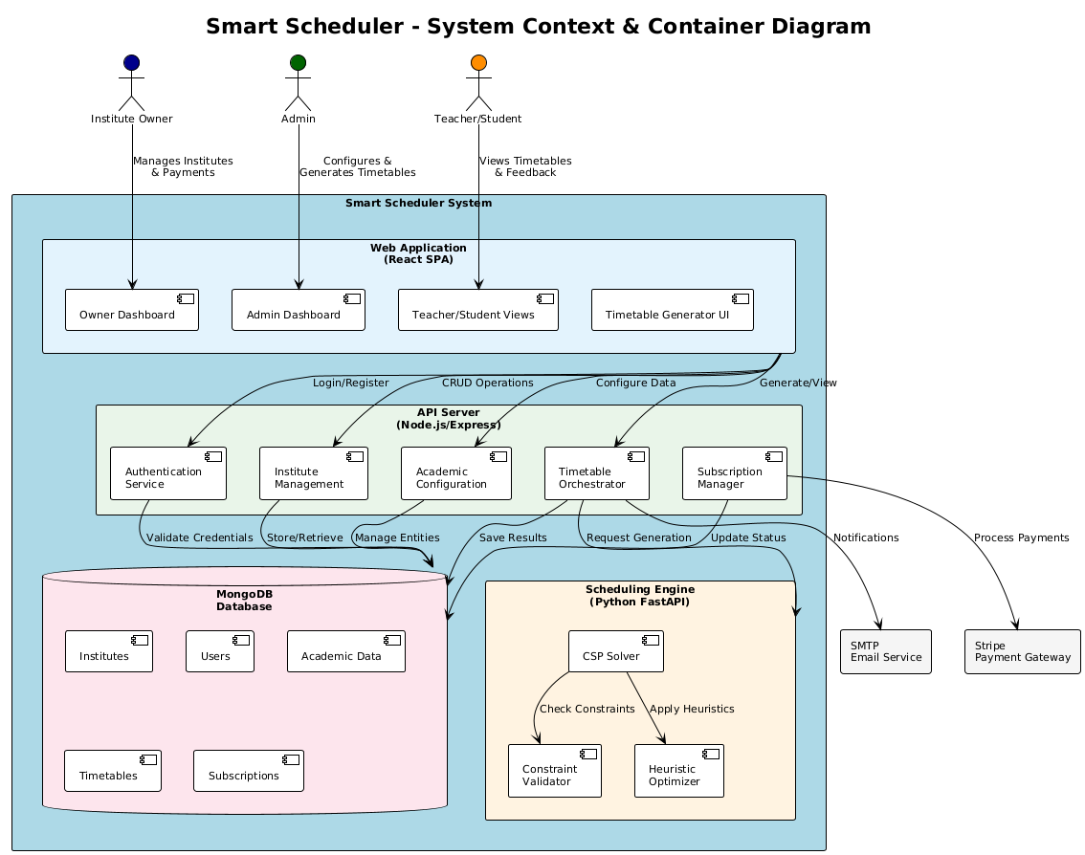

5.1.1 Component Diagram (Logical)
- REST + JWT
- Mongoose
- HTTP POST
- React Frontend (Port 3000)
- Node/Express API (Port 5000)
- MongoDB
- FastAPI CSP Solver (Port 8000)
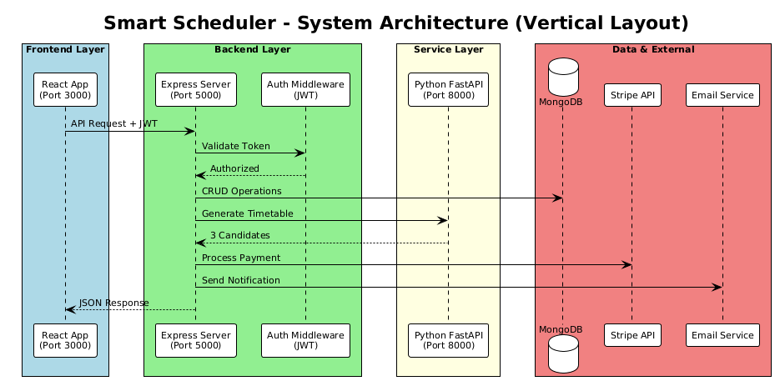

5.2 Backend Design (Express)
Key backend modules:
- Auth and JWT token issuance
- CRUD modules: rooms, classes, courses, time slots
- Timetable generation orchestration (calls Python) and timetable persistence
- Feedback threads + message replies
- Subscription status and payment features (Stripe)

5.3 Database Design (MongoDB)
MongoDB stores institute and academic entities. Major collections include:
- InstituteInformation: institute metadata and subscription type
- Users and OwnerUser: role-based accounts
- Room, Class, Course, TimeSlot
- InstituteTimeTables and InstituteTimeTableDetails with saved timetables
- InstituteSubscription: payment records
- Feedback and FeedBackMessages: support/feedback module
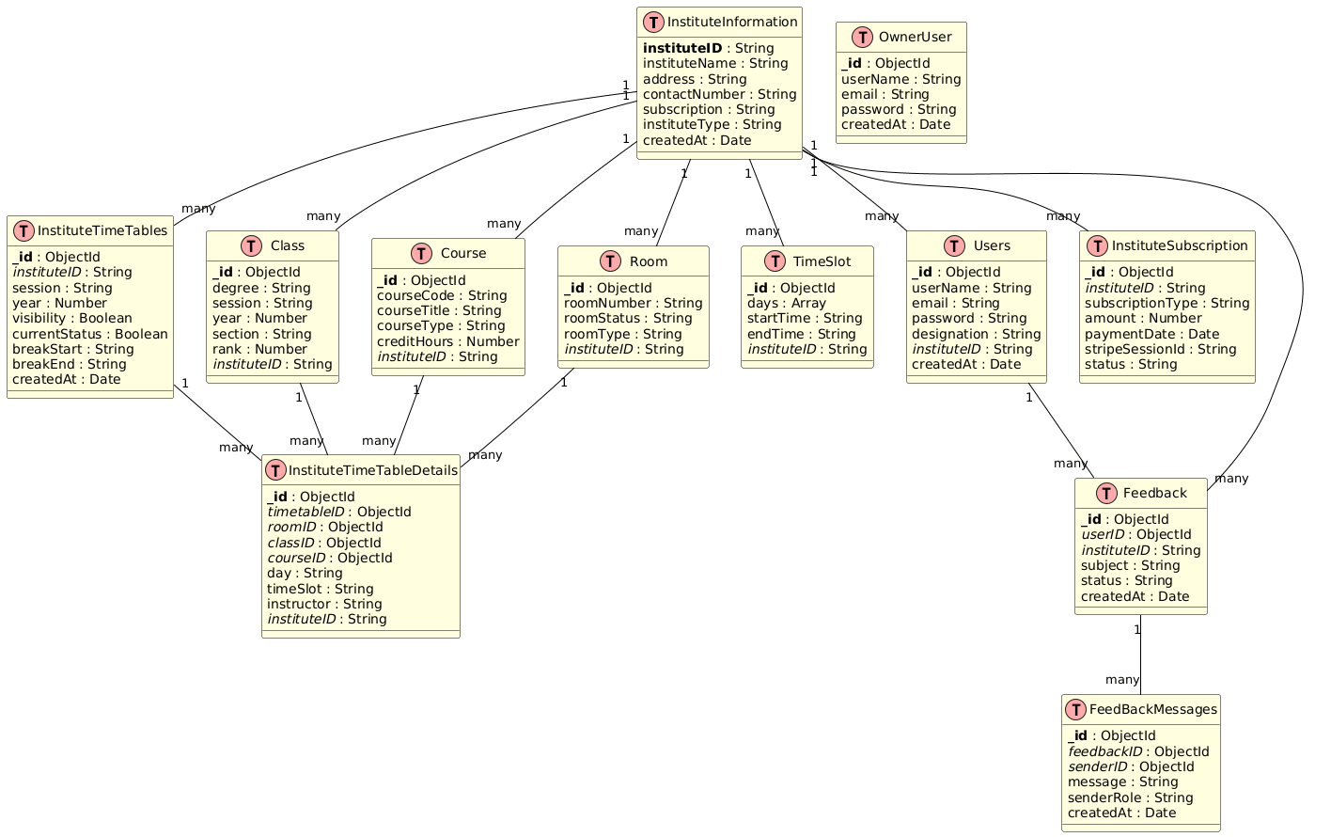

5.3.1 Timetable Storage Strategy
A saved timetable is represented by:
- Header document (InstituteTimeTables) containing timetable id, session/year, visibility/currentStatus and optional break window
- Detail rows (InstituteTimeTableDetails) containing each scheduled session (room, class, course, day, time, instructor)

5.4 Frontend Design (React)
The frontend of Smart Scheduler is developed using React, providing a responsive and interactive user interface for all institute roles. Key design features include:
Routing: The application utilizes react-router-dom to manage client-side routing, enabling seamless navigation between pages and components.
Route Protection: Access to specific routes is controlled using a custom PrivateRoute component, ensuring that users can only access features relevant to their role (Owner, Admin, Teacher, Student).
Subscription Gating: The frontend implements subscription checks for institute roles, restricting access to premium features based on the institute’s subscription status (Trial, Monthly, Yearly). Expired or unauthorized users are redirected appropriately.
UI Components and Dashboards: The interface leverages Bootstrap for consistent styling and layout, and integrates charting libraries to present dashboard analytics and visual summaries of timetable data.
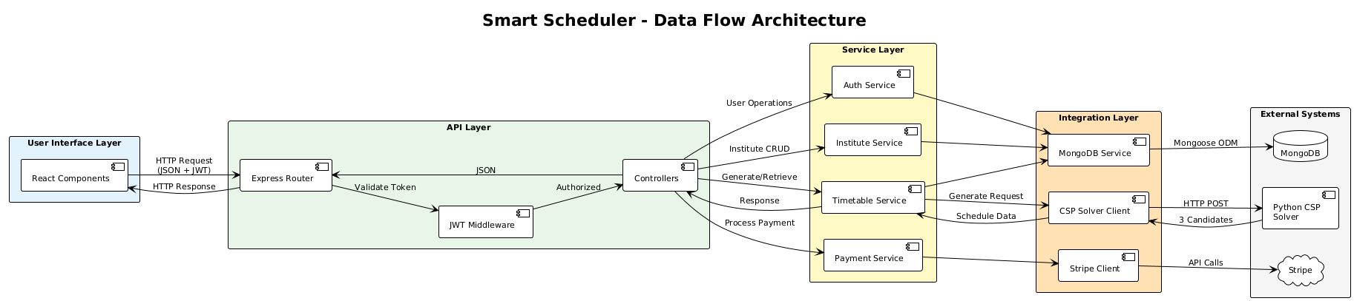
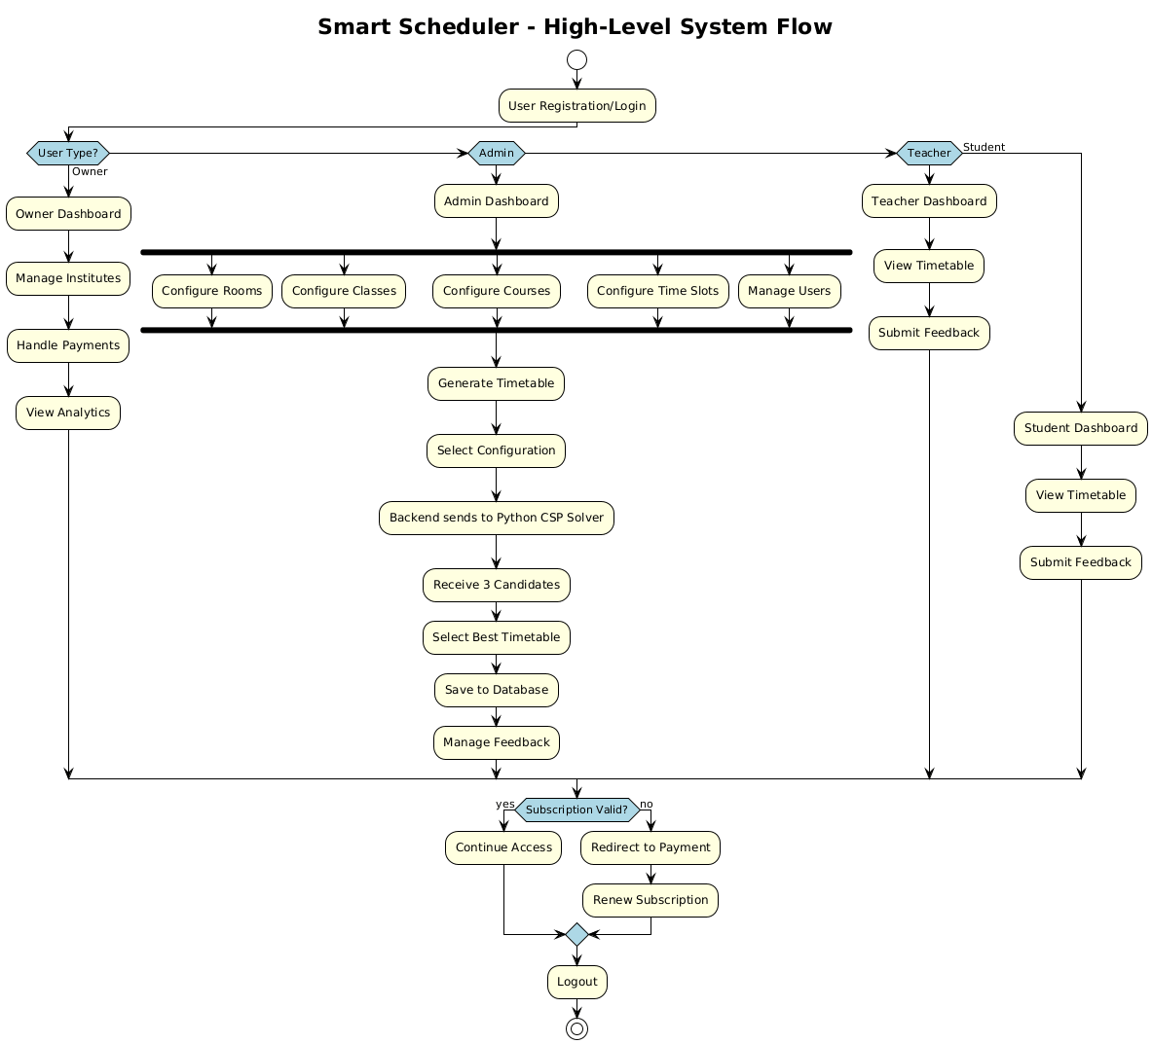

Chapter 6 - Implementation

6.1 Technology Stack
- Frontend: React 18, React Router, Axios, Bootstrap, Chart.js
- Backend: Node.js, Express, Mongoose, JWT, Passport (Google OAuth), Nodemailer, Stripe
- Database: MongoDB (local or Atlas)
- Scheduler Service: Python 3 + FastAPI + Pydantic

6.2 Authentication and Authorization
- Backend issues JWT tokens with: user id, username, role/designation, and instituteID
- Frontend stores token in localStorage and sends it in Authorization: Bearer <token>
- Protected routes enforced in both backend middleware and frontend routing

6.3 Subscription Enforcement
- Endpoint /api/subscription/status/:instituteID calculates expiry:
  - Trial window (default 14 days)
  - Rolling Monthly/Yearly periods based on last payment
- Frontend PrivateRoute redirects expired users (unless explicitly allowed for profile pages)

6.4 Timetable Generation Flow (End-to-End)
- Admin configures rooms, classes, courses, and institute daily time windows.
- Admin runs a multi-step wizard to:
  - select rooms
  - map classes to class-rooms and lab-rooms
  - map courses per class
  - assign teachers per class-course
  - set break window and lecture duration (slotMinutes)
- Frontend calls backend endpoint:
  - POST /api/timetables-gen/generate
- Backend loads institute time windows from DB (TimeSlot), builds payload, and calls Python:
  - POST http://<PY_API_URL>/timetables/generate
- Python generates three candidates using seeds 42, 1337, 2025.
- Admin selects a candidate and saves it via:
  - POST /api/timetables-gen/save

6.5 CSP Solver Design (Python FastAPI)

6.5.1 CSP Modeling
- Variables: each required session for a (class, course)
  - Lecture variables: one per credit hour (e.g., 3 credit hours → 3 lecture sessions)
  - Lab variables: one variable representing a block of consecutive slots
- Domains: possible assignments for each variable:
- (room, day, time_slots)
- Lecture uses one slot; lab uses 3 consecutive slots (fallback to 2 if needed)

6.5.2 Hard Constraints (Must Satisfy)
- No room conflicts: same room cannot be used at overlapping times
- No class conflicts: class cannot have overlapping sessions
- No instructor conflicts: instructor cannot teach overlapping sessions
- Break respect: no session overlaps break window
- Lab consecutive scheduling: labs use consecutive slots

6.5.3 Soft Constraints (Preferences)
The solver assigns scores to candidate values to prefer:
- Avoid multiple sessions of the same course on the same day
- Spread sessions across days (avoid day overload)
- Avoid back-to-back same-course sessions
- Balance instructor workload
- Prefer middle time slots (between 9AM–5PM)
- Minimize large gaps in a class schedule
- Prefer matching room types (lab rooms for labs)

6.5.4 Search Strategy
- Backtracking search
- MRV variable ordering
- LCV via soft-constraint score ordering
- Forward checking to prune domains
- Time-bounded solving (default max 8 seconds per candidate)

Chapter 7 - Testing and Validation

7.1 Testing Strategy
A comprehensive testing strategy was adopted to ensure the reliability and correctness of the Smart Scheduler system:
Unit-Level Checks (Solver): The CSP solver includes unit tests for core functionalities such as constraint validation, overlap detection, and domain generation. These tests verify that individual components of the scheduling logic behave as expected under various scenarios.
Service-Level Checks (Python API): The Python FastAPI service is tested to ensure it consistently returns three candidate timetables for valid input, or provides clear and structured error messages when constraints cannot be satisfied or input is invalid.
API-Level Checks (Backend): The backend API performs validation of assignment payloads, including checks for credit hours and data consistency. It also ensures that any errors or exceptions from the solver service are correctly propagated to the frontend, maintaining robust end-to-end error handling.

7.2 Python Solver Realistic Test
To validate the CSP solver's performance and correctness, a comprehensive test script (test_realistic.py) has been developed that simulates real-world scheduling scenarios with multiple classes, laboratory sessions, and lecture sessions.
The test executes the generate candidate function with a fixed random seed to ensure reproducibility and enable consistent performance benchmarking across test runs.
Key Metrics Captured:
Performance Metrics: Constraint checks performed, backtrack operations, and search depth
Schedule Quality Metrics: Session distribution across days, gap minimization, room utilization efficiency, break-time compliance, and consecutive slot allocation for labs
These metrics provide insights into both the computational efficiency of the solver and the practical quality of generated timetables, ensuring the system meets performance and functional requirements.

7.3 Validation Criteria
A generated timetable is considered valid and acceptable for deployment only if it satisfies the following validation criteria:
No Resource Conflicts: Each room, class section, and instructor must be assigned to only one session at any given time, ensuring zero scheduling overlaps
Break Time Compliance: All scheduled sessions must respect the designated break window, with no teaching activities occurring during institutional break periods
Slot Duration Accuracy: Each lecture session duration must conform to the configured slotMinutes parameter, maintaining consistency across the timetable
Lab Session Continuity: Laboratory sessions must be allocated in consecutive time slots (typically 2-3 consecutive slots) to accommodate practical work requirements without interruption.
The validation process is automatically performed by the CSP solver's constraint-checking mechanism, ensuring that only feasible and conflict-free timetables are generated and presented to administrators for selection.

Chapter 8 - Results and Discussion

8.1 Timetable Generation Output
The Smart Scheduler system successfully generates three distinct candidate timetables for each scheduling request by utilizing different random seeds (42, 1337, and 2025) in the CSP solver. This multi-candidate approach provides administrators with meaningful alternatives, each representing a valid conflict-free schedule that satisfies all hard constraints while optimizing different soft preferences.
Benefits of Multiple Candidates:
- Provides flexibility in selecting schedules that align with institutional priorities
- Allows comparison of different session distributions across days
- Enables administrators to choose timetables with preferred gap patterns or instructor workload distributions
- Increases the likelihood of finding an optimal solution that satisfies both technical and practical requirements

8.2 Performance Analysis
The system demonstrates efficient performance through its distributed architecture:
Backend Performance:
- The Node.js/Express backend remains lightweight and responsive, primarily handling API routing, authentication, and database operations
- Average response time for CRUD operations: < 200ms
- Timetable save operations complete within 1-2 seconds
Solver Performance:
Primary computational workload is isolated in the Python FastAPI microservice
CSP solver employs intelligent heuristics (MRV, LCV, Forward Checking) to reduce search space
Time-bounded search with default 8-second limit per candidate ensures system responsiveness
Typical generation time for moderate-sized institutions (5-10 classes, 20-30 courses): 15-30 seconds for all three candidates. The solver tracks performance metrics including constraint checks and backtrack operations for monitoring and optimization

8.3 System Strengths
Architectural Advantages:
Clear Separation of Concerns: Business logic (MERN stack) is completely decoupled from scheduling engine (Python CSP), enabling independent maintenance and scaling
Constraint Satisfaction Guarantee: CSP-based approach mathematically ensures conflict-free schedules that satisfy all hard constraints
Real-World Applicability: Successfully handles practical institutional requirements including break times, laboratory consecutive slots, and varying lecture durations
Functional Strengths:
Role-Based Access Control: Comprehensive user management supporting Owner, Admin, Teacher, and Student roles with appropriate permissions
Subscription Management: Integrated payment system with Stripe enables sustainable business model
Flexibility: Supports diverse institutional configurations including multiple room types, varying credit hours, and customizable time windows
User Experience: Multi-step wizard simplifies complex timetable generation process for administrators

8.4 Current Limitations and Trade-offs
Scheduling Constraints:
Flexible Room Type Assignment: While the system prefers matching room types (labs in lab rooms), it allows flexibility when strict matching would prevent finding a solution. This pragmatic approach prioritizes schedule feasibility over absolute room-type enforcement
Limited Instructor Preference Optimization: The system ensures instructor availability and workload balance but does not currently incorporate individual instructor preferences for specific time slots or days
Scalability Considerations:
Large Institution Performance: Very large institutions (20+ classes, 100+ courses) may require increased solver time limits or additional heuristic optimizations
Time Limit Trade-off: The 8-second time bound per candidate balances responsiveness with solution quality; complex scenarios may occasionally require manual time limit adjustments
Future Enhancement Opportunities:
- Teacher preference learning and integration
- Advanced room-type strictness configuration options
- Enhanced analytics and reporting features
- Automated solver parameter tuning based on institution size
Despite these limitations, the system successfully addresses the core problem of automated timetable generation and provides a robust, production-ready solution for educational institutions.

Chapter 9 - Deployment and User Guide

9.1 Local Deployment (Development)
Backend
- Location: backend/
- Start: npm run dev (port 5000)
Frontend
- Location: frontend/
- Start: npm start (port 3000)
- Frontend uses proxy: http://localhost:5000
Python Scheduler Service
- Location: api/python/, Run: uvicorn app:app --host 0.0.0.0 --port 8000

9.2 Environment Variables (Typical)
Backend .env (examples):
- MONGODB_URI
- JWT_SECRET, JWT_EXPIRE
- FRONTEND_URL, SESSION_SECRET
- PY_API_URL (defaults to http://localhost:8000)
- Stripe: STRIPE_SECRET_KEY, STRIPE_WEBHOOK_SECRET, STRIPE_CURRENCY

9.3 Admin Workflow (Timetable)
- Configure Rooms → Classes → Courses → Time Slots
- Generate Timetable → review candidate schedules → Save
- Publish visibility/current status using timetable header settings

Chapter 10 - Conclusion and Future Work

10.1 Conclusion
The Smart Scheduler project successfully addresses the complex challenge of automated academic timetable generation through an innovative integration of modern web technologies and constraint satisfaction problem-solving techniques. The system delivers a comprehensive, production-ready solution that transforms the traditionally manual and error-prone process of timetable creation into an efficient, automated workflow.
Key Achievements:
The project accomplishes its primary objectives by delivering:
- A complete institute management ecosystem supporting multiple user roles (Owner, Admin, Teacher, Student) with secure role-based access control via JWT authentication
- An intelligent CSP-based timetable generation engine that guarantees conflict-free schedules while respecting institutional constraints including room availability, instructor conflicts, break times, and laboratory session requirements
- A multi-candidate generation strategy that produces three distinct valid timetables, empowering administrators to select the most suitable schedule for their institutional needs
- Seamless integration between a MERN stack web application and a Python FastAPI microservice, demonstrating effective service-oriented architecture
- Business sustainability features including Stripe payment integration, subscription management (Trial, Monthly, Yearly plans), and automated expiry enforcement
- Communication channels through integrated feedback and messaging systems for institutional stakeholders
Technical Contributions:
- Constraint Satisfaction Problem solving with MRV, LCV, and Forward Checking heuristics
- Microservices architecture separating business logic from computational algorithms
- RESTful API design with proper authentication and authorization middleware
- Responsive React-based user interfaces with role-specific dashboards and workflows
- NoSQL database schema design optimized for academic scheduling data
Practical Impact:
Smart Scheduler provides educational institutions with a reliable, scalable platform that significantly reduces administrative overhead in timetable management while ensuring schedule quality and constraint compliance. The system's flexibility in handling diverse institutional configurations makes it adaptable to various educational contexts.

10.2 Future Work
While the current implementation successfully meets its core objectives, several enhancements could further improve the system's capabilities and user experience:
Scheduling Engine Enhancements:
Configurable Room-Type Strictness: Implement administrator-configurable enforcement levels for room type matching, allowing institutions to choose between strict lab-room-only policies or flexible assignment based on their priorities
Instructor Preference Integration: Develop a preference management system where teachers can specify preferred time slots, days off, and workload distribution preferences, integrating these as weighted soft constraints in the solver
Advanced Optimization Objectives: Add support for multiple optimization goals such as minimizing instructor idle time, balancing workload across days, and clustering related courses
User Experience Improvements:
Enhanced Reporting and Export Capabilities: Implement PDF generation for printable timetables, Excel export functionality, and customizable timetable views with filtering and grouping options
Visual Timetable Editor: Add drag-and-drop manual adjustment capabilities for administrators to fine-tune automatically generated timetables
Real-time Notifications: Integrate email/SMS notifications for timetable updates, schedule changes, and subscription reminders

Administrative Features:
Comprehensive Audit Logging: Implement detailed activity logs tracking all timetable modifications, user actions, and system events for accountability and compliance
Granular Permission System: Extend role-based access control with customizable permissions allowing fine-grained control over feature access
Analytics Dashboard: Develop advanced analytics for room utilization statistics, instructor workload analysis, and scheduling pattern insights
Scalability and Performance:
Solver Optimization: Implement adaptive time limits and parallel candidate generation for large institutional datasets
Caching Strategies: Add intelligent caching for frequently accessed timetables and configuration data
Database Indexing: Optimize MongoDB indexes for improved query performance at scale
Integration Capabilities:
External System Integration: Develop APIs for integration with existing student information systems, learning management platforms, and institutional databases
Calendar Synchronization: Enable export to popular calendar formats (iCal, Google Calendar) for seamless personal schedule management
These enhancements would transform Smart Scheduler from a robust scheduling solution into a comprehensive academic management platform, further increasing its value proposition for educational institutions.

References
- MongoDB, Inc. (2025) MongoDB Documentation.
Available at: https://docs.mongodb.com/manual/
- OpenJS Foundation (2025) Express.js Documentation.
Available at: https://expressjs.com/
- Meta Platforms, Inc. (2025) React Documentation.
Available at: https://react.dev/
- Ramírez, S. (2025) FastAPI Documentation.
Available at: https://fastapi.tiangolo.com/
- Stripe, Inc. (2025) Stripe API Documentation.
Available at: https://stripe.com/docs/api

Appendices

Appendix A - Key API Endpoints (Backend)
- Auth: /api/auth/*
- Users: /api/users/*
- Rooms: /api/rooms/*
- Classes: /api/classes/*
- Courses: /api/courses/*
- Time Slots: /api/timeslots/*
- Timetable Generation: /api/timetables-gen/*
- Feedback: /api/feedback/*
- Subscription: /api/subscription/*
- Payments: /api/payments/*

Appendix B - Python Scheduler Endpoint
- POST /timetables/generate → returns { candidates: [ {header, details, stats}, ... ] }

Appendix C - Data Model Summary (Core Fields)
- InstituteInformation: instituteID, instituteName, address, contactNumber, subscription, instituteType
- Users: userName, email, designation, instituteID
- Room: roomNumber, roomStatus, instituteID
- Course: courseCode, courseTitle, courseType, creditHours, instituteID
- Class: degree, session, year, section, rank, instituteID
- TimeSlot: days, startTime, endTime, instituteID

Appendix D - Timetable Payload Structure
{
"instituteID": "...",
"session": "Fall",
"year": 2025,
"classes": ["BS CS 1-A"],
"assignments": [
{"class": "BS CS 1-A", "course": "Data Structures", "type": "Lecture", "creditHours": 3, "instructor": "..."},
{"class": "BS CS 1-A", "course": "DS Lab", "type": "Lab", "creditHours": 3, "instructor": "..."}
],
"rooms": ["F101", "LabB101"],
"roomTypes": {"F101": "Class", "LabB101": "Lab"},
"timeslots": [{"day": "Mon", "start": "09:00", "end": "15:00"}],
"breaks": {"mode": "same", "same": {"start": "12:00", "end": "12:30"}},
"slotMinutes": 60,
"algorithms": ["CSP"]
}

